Hemp Flower and Holistic Wellness: Exploring Natural Benefits
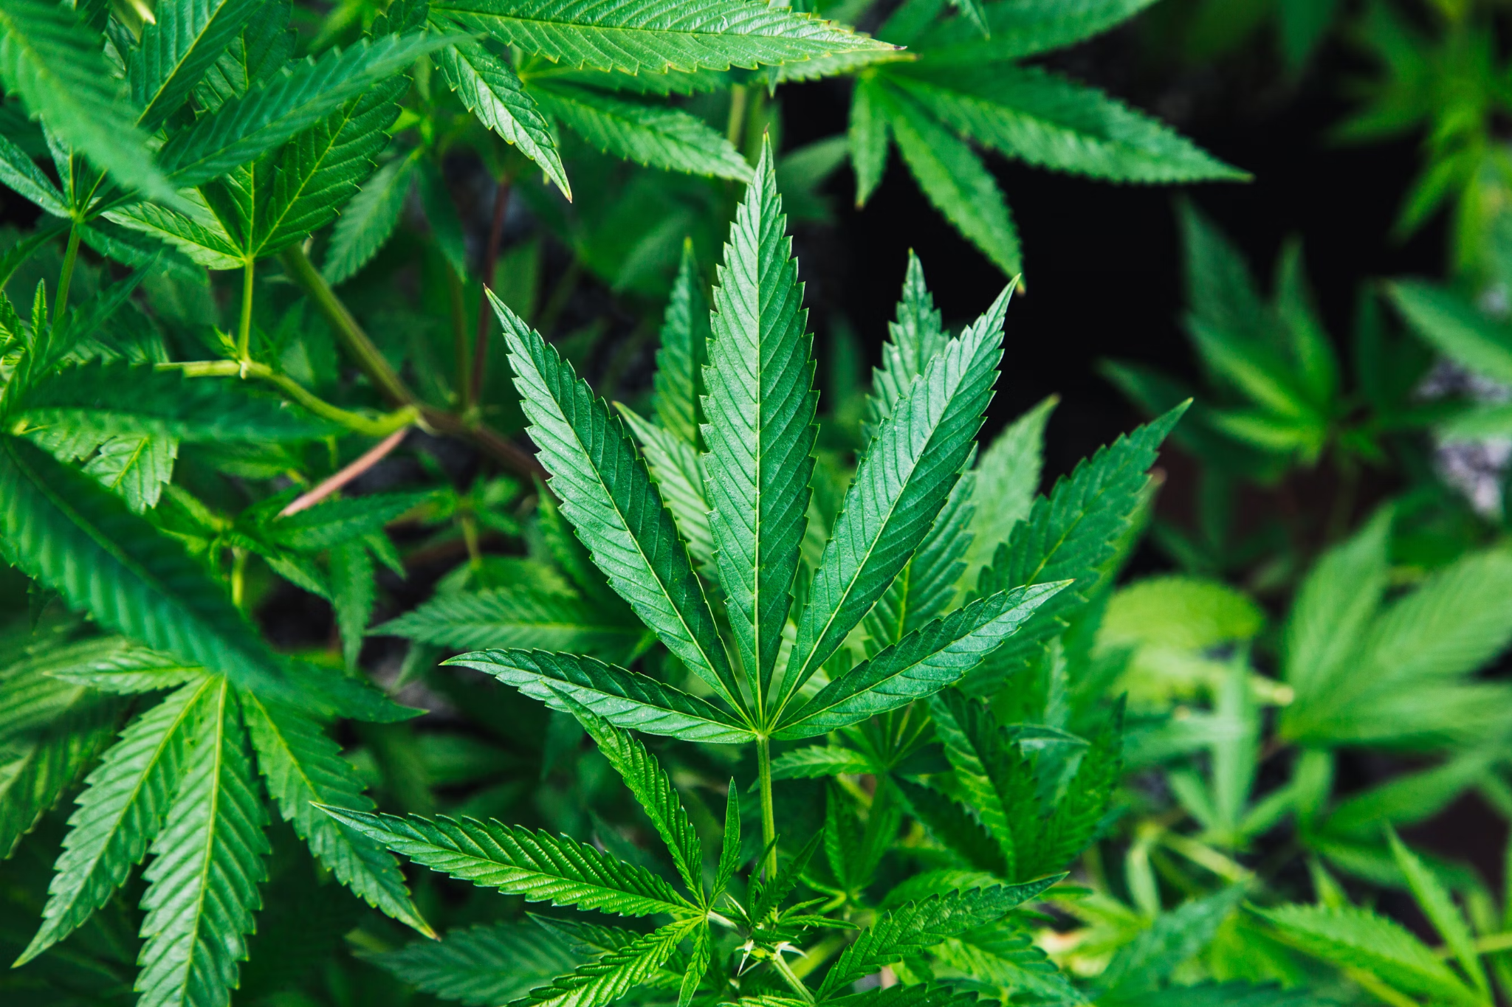
Hemp flower refers to the buds of the hemp plant, which contain a variety of natural compounds, including cannabidiol (CBD), terpenes, and other cannabinoids. These flowers are cultivated from hemp strains low in THC, ensuring they don’t produce the psychoactive effects often associated with marijuana.

Instead, flower is rich in CBD, which interacts with the body’s endocannabinoid system to provide potential wellness benefits without intoxication. As the demand for natural remedies grows, flower has emerged as a popular choice for those interested in holistic health and wellness.

How It Differs from Other CBD Products
While CBD oil, capsules, and topicals are common, hemp offers a distinct experience due to its “entourage effect” (source: https://prototype.phenohunter.org/index.php?threads/the-entourage-effect.173/) This term describes how cannabinoids and terpenes interact to create a more balanced impact, enhancing the flower’s effects. When the flower is consumed in its natural state, it contains a full spectrum of cannabinoids and terpenes that work together to influence wellness. Many users report that the entourage effect creates a well-rounded sense of relaxation and relief. For those looking for a comprehensive CBD experience, hemp provides an alternative to isolated products.

The Role of Terpenes in the Effects
A key feature of flower is its rich terpene profile, which not only gives each strain its unique aroma but also contributes to the plant’s effects. Terpenes are organic compounds found in various plants, influencing factors like scent and taste. In flower, terpenes like myrcene, limonene, and pinene play a role in how the flower impacts mood and relaxation.

For instance, myrcene is known for its sedative properties, while limonene may provide an uplifting, citrusy aroma that can improve mood. Understanding terpene profiles helps users select flower strains that align with their wellness needs.

Stress Relief and Relaxation
One of the most common uses for hemp is managing stress. With CBD’s interaction with the endocannabinoid system, many users experience a calming effect that doesn’t impair their mental clarity. Most hemp flower allows users to unwind naturally. This provides an option to reduce stress levels without relying on pharmaceutical products.

Its gentle effects make it suitable for those who want a subtle sense of relaxation without feeling drowsy. For people facing daily stressors, flower can be a valuable addition to their routine, offering a natural way to achieve a state of calm.

Supporting Sleep
Hemp flower may also offer benefits for those struggling with sleep issues. Some strains, especially those high in the terpene myrcene, have relaxing properties that can make it easier to fall and stay asleep. By choosing strains with sedative terpenes, users can create a bedtime routine that encourages natural restfulness.

Unlike some sleep aids, flower doesn’t produce grogginess or dependency, making it a safe alternative for improving sleep quality. For individuals seeking a more holistic approach to sleep, flower provides an option aligned with natural health principles.

Pain Management Potential
In addition to relaxation and sleep support, flower may help manage pain and discomfort. CBD has anti-inflammatory properties, which could reduce discomfort related to chronic conditions, physical activity, or injuries. For those looking to avoid over-the-counter pain medications, flower offers a plant-based option that may relieve soreness or muscle tension. The cannabinoids in hemp interact with receptors in the nervous system, potentially reducing pain perception without side effects. For anyone considering a natural approach to managing pain, hemp provides a promising solution.

Choosing the Right Strain for Your Wellness Goals
With numerous strains available, selecting the right one for specific wellness needs is essential. Strains vary in their CBD and terpene profiles, which influence how they interact with the body. For example, those seeking stress relief might look for strains with calming terpenes, while users interested in uplifting effects may prefer strains high in limonene.

Consulting product descriptions and lab results can provide insights into each strain’s composition, allowing users to choose based on their wellness priorities. Experimenting with different strains can help find the best match for individual goals.

Sustainable Aspects of Production
Hemp is also a sustainable choice in the wellness market, as hemp plants grow quickly and require minimal resources. Known for their environmental benefits, hemp plants improve soil health by absorbing heavy metals and releasing nutrients back into the ground. Additionally, hemp requires less water than many crops, making it an eco-friendly option for environmentally conscious consumers.

Choosing hemp supports sustainable agricultural practices, aligning with values of those interested in holistic and responsible wellness. As the industry expands, more companies are adopting eco-friendly methods to produce high-quality hemp.

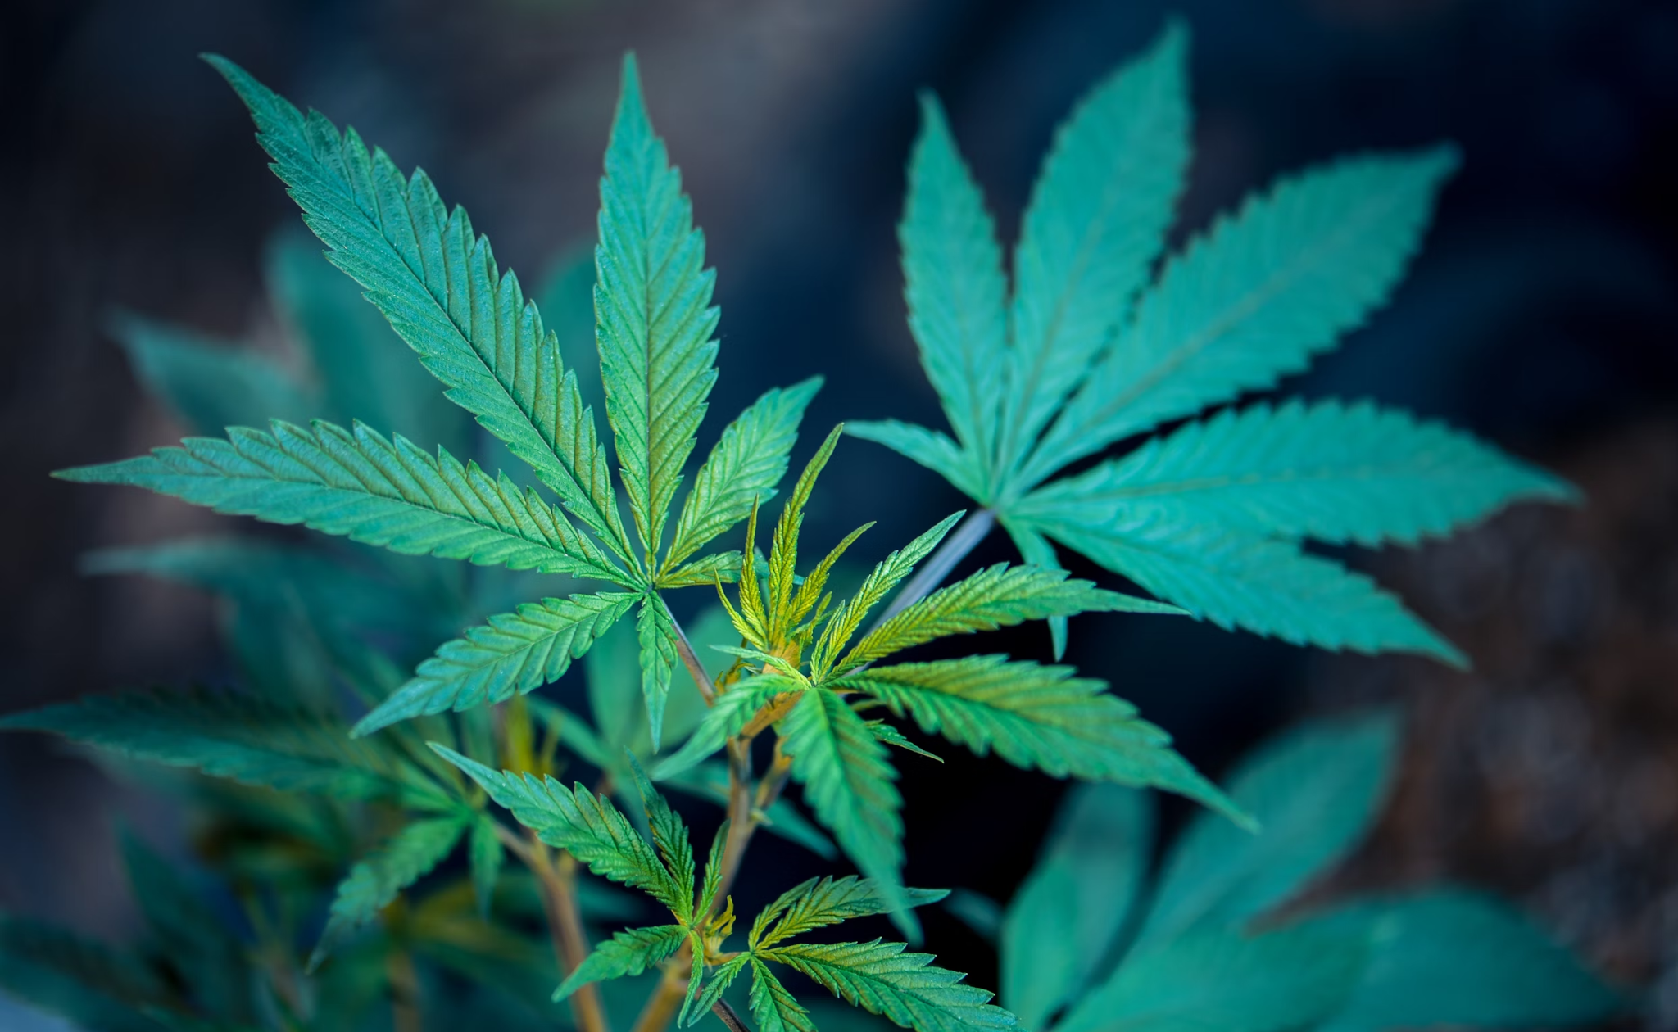

Different Ways to Enjoy
There are several ways to incorporate it into a wellness routine, allowing users to choose methods that suit their preferences. This forum suggests that smoking and vaporizing are popular choices, offering immediate effects as the compounds quickly enter the bloodstream. Those who prefer not to inhale can use it to make homemade tinctures, edibles, or topicals. This versatility lets users tailor their experience and try different methods to see which one best supports their needs. With so many ways to use it, it fits seamlessly into various wellness lifestyles.

Tips for Responsible Use
While hemp is generally safe, using it responsibly is key to maximizing benefits. Beginners should start with a small amount to gauge how their body responds, as effects can vary from person to person. It’s also important to buy from reputable sources, as quality and potency differ among products. Checking lab reports ensures that the plant is free from contaminants, providing a safe experience. Responsible use includes staying mindful of dosage, choosing the right strains, and selecting products from trusted brands.

My Final Thoughts
Hemp flower is becoming a trusted option for those seeking natural wellness solutions. Its potential to support relaxation, manage pain, and enhance sleep positions it as a valuable tool in holistic health. By understanding the various aspects of flower, such as its terpene profiles and different methods of use, individuals can tailor their experience to meet specific needs. As interest in sustainable, plant-based wellness grows, flower stands out as a versatile, eco-friendly choice for achieving a balanced lifestyle.

